Installing a Printer on a PC

1. First thing’s first, you need to get the IP (Internet Protocol) address of the printer. This can usually be found somewhere on the front or side of the printer. It will start with 10.10.10 and end with a varying number. That last number is the one that you need.
2. Once at your PC, navigate to the menu option labeled **Devices and Printers**, located in the ‘Start’ menu (on most Windows PCs, there is a key with a flag icon on it labeled ‘start’ – this will open that menu and the Control Panel should be on the right, near the bottom.  
   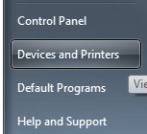
3. Your screen should look like this (minus the warning icon)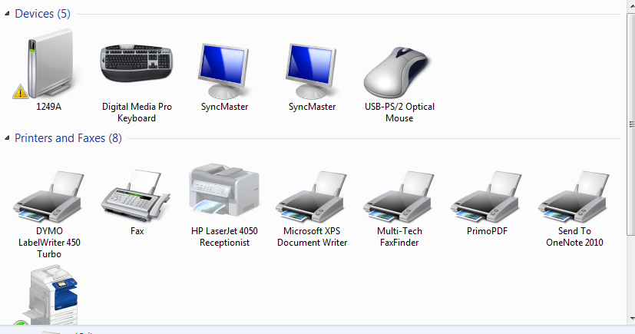
4. Look up near the top left-hand corner and there should be a button called **Add a Printer** – click *this*, and *not* **Add a Device**! It makes all the difference as to what kind of device (and, subsequently, the driver of) you are attempting to add.  
   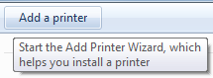
5. When the new window pops up asking what kind of printer you wish to add, choose **Add a Local Printer**. Even though the printer is being installed on the network, we must add it locally – this is very important.  
   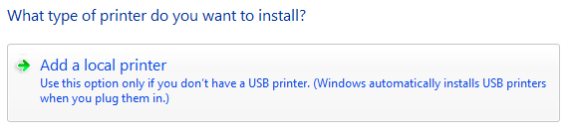
6. Next, on the following screen, tick the selection box titled “**Create a New Port.**”
7. Once the box is ticked ‘on’, choose “**Standard TCP/IP Port**” from the dropdown list next to it.  
   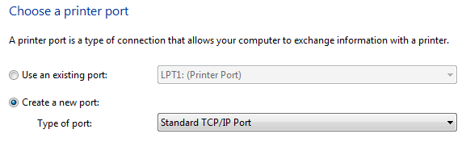
8. Now is when you will need the IP address procured from your printer in the first step. Once the new screen loads, it will prompt you for two things: the IP address and the Port name. Once you begin filling out the IP address field, the Port name field will automatically update to match it. Leave it be until you’re done with the former. Now, using the exact IP located on the sticker on your printer, type it in to the IP address field, in its entirety. The printer I will be using has the IP address of 10.10.10.101 (all of the printer IPs will start the exact same, as for the first three numbers). Once the IP is typed in, name the Port something you can remember and recognize, and then make sure that you do *not* tick the checkbox that reads “**Query the printer and automatically select the driver to use**”.  
   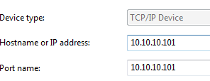
   1. **NOTE:** If installing a special printer (such as the PX4i 203 dpi 3x2 label printer in shipping), there will be additional steps that must be taken. It will ask for what *kind* of port you wish to use – the Generic is fine. Also, once this printer is fully installed (FOR SPECIAL PRINTERS ONLY), change its port from **9100** to **9101**.
9. You will get a screen that looks like the one below. On the left-hand side is the brand of the printer. The one I am using is an HP and is therefore what I will choose. On the right-hand side is the make of the printer. Mine is a LaserJet 4050 PCL 5, so that is what I will select (do not select Post Script or PCL6).  
   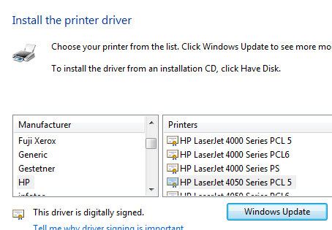
10. You will get one of two screens: either it will ask you for the name of the printer (use the name that’s already in the box, if there is one, and add your name to it), or it will tell you that the driver is already installed (if this is the case, simply select the **Use the driver that is currently installed**).  
    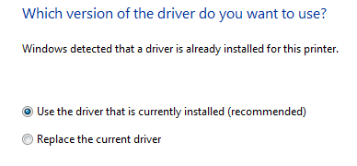
11. After you click Next, if it hasn’t already, it will ask you for the name. If there is already a value there, leave it – if not, name it what you wish.
12. The PC will then begin installing your printer. Once the next Window pops up that asks you whether you would like to share it or not, choose **Do not share this printer**.  
    
13. The last Window will ask you if you wish to make this printer the default. This is completely up to you, but I will leave mine off (simply tick the box to turn it off, as it is already turned on by default). The next thing you want to do, to be sure that the printer actually works and is configured correctly, is click on **Print a test page**. This will query the printer to send out a piece of paper that the computer asks it to.  
    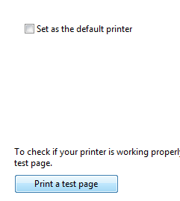
14. The page printed should have all kinds of data on it, and will be titled “**Windows Printer Test Page**”.
15. Click **Finish**, and then you’re done. Enjoy using the new printer.